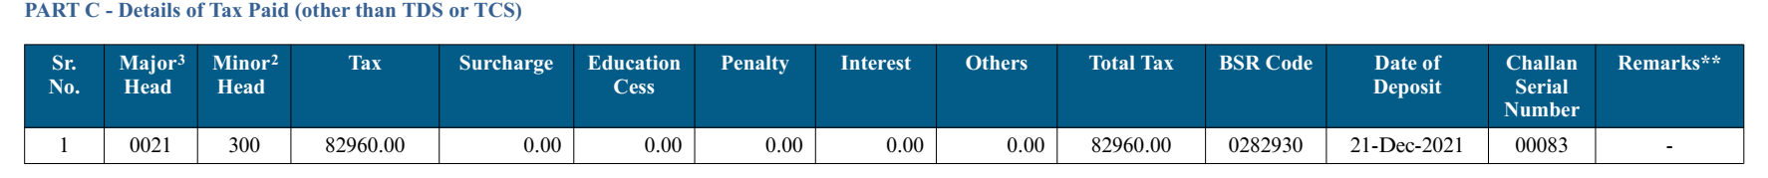

Bank Statement

|  |  |  |  |  |  |
| --- | --- | --- | --- | --- | --- |
| ***Post Date*** | ***Value Date*** | ***Branch Code*** | ***Cheque Number*** | ***Account Description*** | ***Debit*** |
| 20/12/2021 | 20/12/2021 | 08103 |  | TO TRANSFER/DIRECT TAX ITNS280:00083 | 82960.00 |
|  |  |  |  |  |  |